**LEBANESE AMERICAN UNIVERSITY**

**USAID – HIGHER EDUCATION SCHOLARSHIP PROGRAM**

**HES - Volunteering Program Verification Form**

This form is to be used to document volunteering hours. If a student volunteers for multiple organizations, a separate form must be used for each organization. **This form must be turned in by the 28th of each month, the latest.**

I certify that the scholar Wissam Albahry completed a total of 5 hours of service at InnovaThrive.

The hours were completed hours as per the below:

Hours # 0 (date) _2/12 – 6/12_ (initials of supervisor) __A.K.___

Hours # 0 (date) _9/12 – 13/12_ (initials of supervisor) __A.K.___

Hours # 0 date) _16/12 – 20/12 (initials of supervisor) __A.K.___

Hours # 5 date) _23/12 - 27/12 (initials of supervisor) __A.K.___

Brief description of the activities the scholar performed or participated in:

I conducted research on how AI enhances customer service through chatbots and virtual assistants. My work focused on exploring technologies like Natural Language Processing (NLP) for understanding customer queries and machine learning for personalizing interactions. I analyzed applications such as 24/7 support, personalized recommendations, and troubleshooting, highlighting their impact on customer satisfaction and cost reduction. Additionally, I examined the advantages of immediate responses and personalization, along with challenges like handling complex or emotional issues. My research also explored future possibilities, including multi-lingual support and proactive customer service solutions.

Written feedback about the scholar’s performance:

Wissam Albahry’s research on AI’s role in enhancing customer service through chatbots and virtual assistants displayed valuable insights and thorough analysis. However, his volunteering form was submitted late. This is unacceptable, as timely submissions are critical to maintaining the efficiency of the program. It is imperative that all forms are submitted by the designated deadline moving forward.

Please rate the overall performance of the scholar at your organization:

|  |  |  |  |
| --- | --- | --- | --- |
|  | Mastery (5) | Proficient (3) | Emerging (1) |
| **Problem solver** | X |  |  |
| **Engaged & Committed** | X |  |  |
| **Open-minded & multicultural** | X |  |  |

Signature

& stamp

__________________________

_

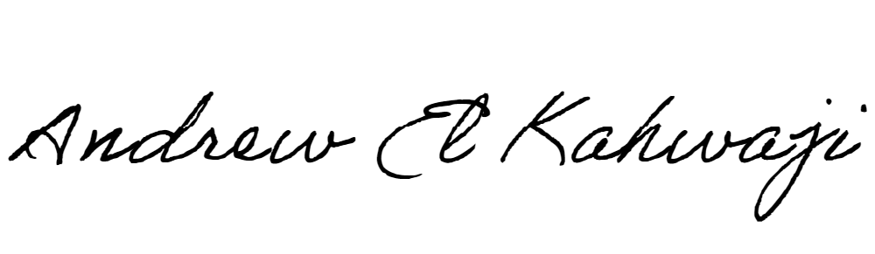

Printed Name _Andrew El Kahwaji_

Date __26/12/2024___

Email __andrew.lifesculptor.coo@gmail.com __

Phone __+961 71 914 378__